Working Paper #90

Exploring the Impact of Energy Efficiency as a Carbon Mitigation Strategy

Marilyn A. Brown, Gyungwon Kim, and Alexander M. Smith

Georgia Institute of Technology

April 2017

ABSTRACT

As temperatures across the globe hit record highs and extreme climate events multiply, interest in least-cost CO₂ mitigation pathways is growing. This paper examines the pros and cons of strengthening demand-side options in strategies to reduce carbon emissions from the U.S. electricity sector. To date, demand-side management in the U.S. power sector has received overly simplistic treatment in energy models. To help fill this gap, we develop a customized version of the National Energy Modeling System to assess a range of demand- and supply-side policy scenarios. This enables four research hypotheses to be tested, related to mitigation costs, investment in new natural gas plants, carbon leakage, and local air pollution.

We conclude that the clean power transformation can be made more affordable by improving the efficiency of energy utilization. By downscaling the construction of natural gas plants, energy efficiency can also avoid legacy impacts. While strong energy-efficiency policies lower overall CO2 emissions, coal plant retirements can be delayed, postponing associated local air quality benefits. Thus, we illustrate a limitation of single-pollutant policies while also demonstrating the value of co-optimizing demand- and supply-side carbon mitigation options.
*Corresponding author: Georgia Institute of Technology
Dr. Marilyn A. Brown D. M. Smith Building
Professor, School of Public Policy Room 107
Email: Marilyn.Brown@pubpolicy.gatech.edu 685 Cherry Street
Phone: 404-385-0303 Atlanta, GA 30332 - 0345

- Introduction
The U.S. electricity sector is in a period of unprecedented change. Natural gas is now generating as much electricity as coal, wind and solar systems are generating as much electricity as hydropower, and energy efficiency is moderating the demand for electricity (US EIA, 2016). As a result, carbon pollution from electricity generation in the U.S. has declined in recent years while the economy has continued to grow. While historic in magnitude, it is unclear that this pace of change can be sustained and ultimately accelerated to achieve the ambitious mid-century climate mitigation goals of the Paris Agreement, to “prevent dangerous anthropogenic interference with the climate system” as specified by the United Nations Framework Convention on Climate Change. Feng et al. (2015) documents that the CO₂ emission reductions between 2007 and 2013, were largely a result of economic recession with changes in fuel mex playing a relatively minor role. The U.S. Energy Information Administration (US EIA, 2015a) estimates that as the U.S. economy expands, its CO₂ emissions will exceed 2012 levels by 7% in 2030 and by 8% in 2040.
This paper examines the role that energy efficiency could play as a U.S. carbon mitigation strategy. We accomplish this by characterizing strong demand-side policies that are then competed against supply-side options using least-cost energy modeling. This approach expands the comprehensiveness of mitigation modeling by assessing both demand- and supply-side options in the U.S., in contrast to the cursory and simplified analysis that energy efficiency has typically received to date.
Section 2 describes the shortcomings that have pervaded the modeling of energy efficiency as a demand-side option in carbon mitigation pathways. Section 3 then presents four hypotheses about the potential impacts of strong energy-efficiency options, that we subsequently test. These relate to compliance costs, investments in new natural gas plants, carbon leakage, and local air pollution. Section 4 describes our research methodology and provides an overview of the modeling tool used to test our hypotheses. Results are presented in Section 5, and the paper ends with conclusions and a discussion of policy implications in Section 6.
- A Gap in the Literature: Shortcomings in Prior Modeling of Energy Efficiency
Over the past several years, energy efficiency has been inadequately assessed in models of U.S. mitigation pathways, relative to the treatment of supply-side compliance options. There are at least three reasons for this.
First, much of the recent modeling of mitigation pathways has focused on ways to meet the requirements of the U.S. Environmental Protection Agency (EPA)’s Clean Power Plan (CPP), which aimed to accelerate the current pace of electricity decarbonization by cutting CO₂ emissions from the electric sector 32% below 2005 levels by 2030 (US EPA, 2015). After issuing proposed rules in 2014, EPA issued final guidelines limiting CO₂ emissions from existing fossil-fueled electric generating units (EGUs) in 2015. Energy efficiency was a building block in EPA’s calculation of state-specific CO₂ caps in the proposed rule, but it was removed from the calculation of limits in the final rule, while remaining an eligible compliance option. This complicated treatment created misunderstandings among analysts and policymakers, some of whom erroneously assumed that end-use energy efficiency was no longer an eligible compliance mechanism (Bushnell, et al., 2017).
Second, stakeholders raised concerns that energy-efficiency carbon allowances and emission rate credits might be difficult to qualify in trading systems because of rigorous monitoring and verification requirements. While energy efficiency as a CO₂ compliance strategy is well honed in some regions where cap and trade systems have operated, other regions have limited experience with it (Chesney, et al., 2016).
Third, most least-cost utility modeling tools are not able to adequately represent energy efficiency. As a result, some studies have ignored energy efficiency entirely when examining CO₂ mitigation options (Peters and Hertel, 2016). Others simply assume an exogenous reduction of energy demand, associated with a step-curve of costs possessing little granularity. Such short cuts are necessary when modeling platforms do not compete energy supply and demand resource options, as is the case with the Integrated Planning Model (IPM) used by EPA (2015a), MJ Bradley & Associates (2016), and the Bipartisan Policy Center (BPC, 2016), the Haiku model used by Resources for the Future (RFF, 2016), US-REGEN used by the Electric Power Research Institute (EPRI, 2016), FACETS-ELC used by Wright and Kunudia (2016), and the MARket ALlocation (MARKAL) model used by Shearer, et al. (2014). While the IPM used by EPA borrows forecasts of peak load and regional electricity consumption from the EIA’s National Energy Modeling System (NEMS), the IPM possesses none of the detailed level of demand-side energy modeling offered by NEMS. After applying an exogenous electricity load forecast, the power sector and its fuel supplies are then modeled. For example, EPA’s Regulatory Impact Analysis (RIA) externally imposes state estimates of energy efficiency as load reductions, assuming that the first 0.5% increment of energy efficiency would cost $1,100/MWh (in $2011) decreasing to a cost of $660/MWh for an increment of 1% (EPA, 2015b, Table 27). BPC (2016) and RFF (2016) assume that the supply of incremental energy efficiency is half the rate of the EPA’s RIA. BPC (2016) uses a 3-step cost curve ranging from $230 to $320/MWh, while RFF (2016) assumes a single undiscounted lifetime cost of $400/MWh.
By treating energy efficiency as an exogenous resource, models cannot reflect interactions such as when supply-side investments elevate electricity prices and make demand-side management more economically attractive. Superior modeling approaches are needed, with highly articulated specifications of end-use technologies embedded in a least-cost optimization algorithm that allows demand- and supply-side energy resources to compete head-to-head.
- Development of Hypotheses
Given the shortcomings of prior least-cost mitigation scenario modeling, it becomes clear that improved modeling could exposit new knowledge about the role of energy efficiency. To structure our inquiry and refine expectations, we propose four research hypotheses.
Hypothesis 1 derives from the large body of literature documenting the low levelized cost of saving electricity (Brown and Wang, 2015). Thus, it postulates that strong energy-efficiency policies would make CO₂ mitigation more affordable. Energy efficiency is seen as the least-cost energy resource with the potential to dominate as a bridge between the Paris Accord and the deeper CO₂ cuts needed to achieve a 2°C maximum threshold for global warming (IEA, 2016). So why aren’t most U.S. utilities taking advantage of this opportunity? In addition to the fact that energy prices do not fully reflect the cost of significant negative externalities such as climate change (National Research Council, 2009), many utilities are still locked into conventional business models with throughput incentives that favor resource expansion over energy efficiency. Policymakers tend to correlate expansion of supply-side resources with economic and employment growth, and utilities focus on expanding generation and transmission resources so that systems are not caught short. Energy efficiency, on the other hand, is seen as a customer service and in standard U.S. utility accounting practice it is categorized as “operations and maintenance.” Analysts increasingly argue that utilities should use least-cost resource planning that considers demand- and supply-side options in a single integrated approach (Brown and Wang, 2015; 2017).
The second hypothesis derives from historical experience documenting how energy-efficiency policies and programs influence the nation’s electricity fuel mix by curtailing the construction of new generating units that would otherwise be required to meet a more rapidly growing demand. Since natural gas combined cycle (NGCC) plants are the least-cost source of new generation (National Academies, 2016), hypothesis 2 postulates that strong energy-efficiency policies would reduce the magnitude of natural gas plant investments and capacity expansions. This hypothesis is critical for several reasons. First, the benefits of natural gas over coal could be mitigated by its potential to delay the adoption of near-zero carbon technologies such as renewables (Hausfather, 2015). Second, evidence suggests that without carbon capture and storage, natural gas power plants could thwart the achievement of deep CO₂ emission reductions. With system-wide U.S. fugitive methane emissions of 2-4% of natural gas production or more (Brandt, et al., 2014), gas plants could produce greater near-term warming potential than similarly sized coal plants (Zhang, et al., 2014).
Hypothesis 3 addresses carbon leakage – the shift of emissions within a state from covered to uncovered fossil generators. Leakage is motivated when compliance designs cause existing steam units and NGCC plants to face compliance costs that new NGCC plants do not, as is the case when mitigation focuses on existing units. Rather than curbing emissions by exploiting low-carbon resources such as renewables, nuclear and energy efficiency, electricity generation may be dispatched less from existing fossil plants and more from new natural gas units (Litz and Murray, 2016). Since strong energy-efficiency policies curb demand growth and the need for new NGCC plants, hypothesis 3 postulates that they would mitigate carbon leakage.
Hypothesis 4 postulates that strong energy-efficiency policies would reduce the emission of local air pollutants such as SO₂, NOx, and mercury. Utilizing energy efficiency in pathways of compliance with CO₂ caps is expected to deliver greater pollution abatement because energy efficiency is one of the cleanest forms of meeting energy service requirements, matched only by nuclear power and a subset of renewables.

- Methodology
To fill the gap in the literature described in Section 2, we evaluate mitigation pathways using the Georgia Tech version of NEMS. GT-NEMS has a highly articulated representation of end-use technologies embedded in a least-cost optimization algorithm that allows demand- and supply-side energy resources to compete head-to-head: contrary to prior modeling approaches, GT-NEMS endogenously models. GT-NEMS therefore represents realistic interactions between carbon regulations and high-efficiency demand-side technologies that prior modeling approaches do not and cannot represent. GT-NEMS serves as an appropriate tool for testing the research hypotheses and providing unique contributions to the literature. This section describes GT-NEMS and the various scenarios we model to help fill this gap.
  - GT-NEMS
GT-NEMS is a multi-sectoral computational general equilibrium model of the U.S. energy economy designed to identify cost-minimizing resource investments to meet energy demand growth. Its platform (NEMS) is the federal government's flagship energy policy model (Cullenward, et al., 2016) – “arguably the most influential energy model in the United States” (Wilkerson, et al., 2013). NEMS has informed a wide array of policy decisions including the debate over whether or not the U.S. should ratify the Kyoto Protocol (Brown, et al. 2001). To achieve our study goals, we created GT-NEMS, a transformed version of the model that generated the energy supply and demand forecasts for the U.S. as published in the Annual Energy Outlook 2015 (US EIA, 2015a). Supplemental materials itemize the differences between NEMS and GT-NEMS.
GT-NEMS is composed of four demand modules (residential, commercial, industrial, and transportation), four supply modules (oil and gas, gas transmission, coal, and renewable fuels), and two conversion modules (electricity and petroleum). In addition, it has an international energy module and an integrating module, and it imports the Global Insights macroeconomic model that is produced and updated every year by IHS. The electricity module performs separate projections of power demand and the cost-minimizing supply necessary to meet that demand for 22 North American Electricity Reliability Corporation (NERC) regions. To evaluate cost-minimizing supply choices, survey data on costs and performance of capacity types as well as end-use load shapes and other key variables are derived from EIA's Forms 860, 861, and 923, Federal Energy Regulatory Commission's Form 1, and NERC projections (Smith and Brown, 2015).
GT-NEMS models the demand sectors using nine Census Divisions. For buildings, appliances, industrial motors and drives, and combined heat and power (CHP) systems, NEMS adds or subtracts from the existing stock to account for new purchases, retrofits, and retirements. For mature technologies, timelines of equipment costs and efficiencies are specified by fuel type. For nascent technologies such as solid state lighting, endogenous learning curves model technology energy performance.
For residential buildings, GT-NEMS uses energy prices and macroeconomic indicators to estimate residential energy consumption for three building types (single-family, multi-family and mobile homes), 21 end-use services, and multiple fuel types. Logit functions assign market shares to competing technologies in ten major end-use services such as space heating, space cooling, and water heating. The implied discount rates are variable (e.g., ranging for space heating and cooling technologies from 15 to 42% – Wilkerson, et al., 2013). Rebound effects are applied to three of these end-uses (heating, cooling, and lighting) and are parameterized to be lower for new versus surviving equipment. For example, new electric heat pumps in the residential sector have rebound effects of 4.02% for heating and 2.43% for cooling; in contrast, for surviving equipment, the rebound effects are 5.25% for heating and 2.96% for cooling. GT-NEMS assumes that a -0.15 short-term price elasticity of residential demand. The relatively low discount rates and price elasticity used in GT-NEMS have been found to slightly under-estimate energy savings; in contrast, the relatively low rebound effects do not consistently alter energy savings in GT-NEMS, perhaps because the macroeconomic model respends savings through purchases elsewhere in the economy with comparable energy inputs and with CO₂ effects that depend upon the carbon intensity of the grid (Cox, et al., 2013; Wang, 2016; Thomas, et al., 2014). Forecasts from commissioned reports are used to characterize 11 minor end-uses (U.S. Energy Information Administration, 2014b). Based on projected building and appliance stocks, the energy integrity of the building envelope is then modeled.
In the commercial sector, GT-NEMS forecasts building stocks and the energy integrity of building envelopes before forecasting the stock of end-use technologies. It characterizes nearly 350 distinct types of end-use equipment and appliances in nine end-uses and eleven types of commercial buildings. GT-NEMS employs a least-cost function within a set of rules governing the options from which building owners and operators may choose technologies. Capital costs are amortized using “hurdle rates”, which are calculated for end-uses by year for different subsets of the population by summing the yield on U.S. government ten-year notes (endogenously determined) and the time preference premium of consumers (exogenous inputs to the model). Ninety percent of commercial floorspace is modeled using effective hurdle rates of 25% or more, and half employ discount rates ranging from 100% to 1000%, which are relatively high compared with past empirical research, causing estimates of energy-savings from demand-side policy interventions to be somewhat under-estimated (Cox et al., 2013). Three different decision types and three types of behavior rules are used depending on whether the technology would be a retrofit, replacement, or new addition, and if there is a change of fuel type (Wilkerson, et al., 2013).
Process energy in the industrial module is modeled separately for 16 manufacturing and 6 non-manufacturing industries, by fuel type. The energy used per dollar of shipments (called unit energy consumption or UEC) is modeled for individual industries, based on energy use per ton of throughput at each process step. Future improvements in UEC are modeled by using Technology Possibility Curves (TPCs), which reflect UECs in the initial year and annual energy intensity declines over time. The TPC rates are estimated separately for retrofitting of existing facilities and for construction of new facilities. The pace of improvement of TPCs in the Reference Case has been shown to underestimate the potential for cost-effective industrial energy efficiency (Brown, et al., 2014). The industrial module specifies cost and performance characteristics for a range of CHP and motor technologies, allowing them to be explicitly modeled (Wang and Brown, 2014).
Across these modules and regions, GT-NEMS projects the production, imports, conversion, consumption, and prices of energy, subject to assumptions about macroeconomic and financial factors, world energy markets, resource availability and costs, behavioral and technological choice criteria, cost and performance characteristics of energy technologies, and demographics (EIA 2009; 2015c).
  - Design of scenarios for modeling carbon mitigation scenarios
Our analysis of CO₂ mitigation options begins by modifying EIA’s 2015 Reference Case to adjust assumptions about various renewable resource costs, technology performance, and recent policies to create an updated Reference case. We then layer on assumptions about stronger energy-efficiency policies, creating a Reference + Energy Efficiency (EE) scenario. The final four scenarios involve two types of strategies to comply with carbon limits (regulating either existing units or all units) with and without the addition of stronger energy efficiency. These are described below; see the Appendix for additional modeling details.
The Updated Reference Case. The updates to the Reference case involved three steps. First, to update estimates of solar PV costs in the GT-NEMS model, we reviewed a diverse range of contemporary estimates of solar PV costs, resulting in a reduction of the trajectory of distributed solar cost assumptions. For example, the updated projection for the installed cost per Watt-dc of distributed commercial PV in 2030 is $1.65 (in $2009), 26% less than the US EIA (2015a) Reference case. For distributed residential PV in 2030, the updated cost is $2.19 per Watt-dc (in $2009), 19% less than the US EIA (2015a) Reference case.
Second, we model the extensions of the wind production tax credit (PTC) and the solar investment tax credit (ITC) that were implemented by the U.S. Consolidated Appropriations Act in 2015. The PTC provided a 2.3 cent per kWh tax credit for the first 10 year of production for plants that are under construction by the end of 2016. It was extended for five years, but the value of the credits decline over the 5-year period. The ITC provides a 30% tax credit for the cost of developing solar energy projects through 2019, when the credit declines incrementally until 2022, when it expires for residential projects and drops to 10% for utility and commercially operated solar projects.
Third, to reflect the design details of the Clean Energy Incentive Program (CEIP) (81 FR 42940, June 30, 2016), we further adjust the solar and wind energy cost assumptions by granting emissions allowances to solar and wind projects that provide energy to the grid in 2020 and 2021. We also slow the rate of decline in the ITC for solar energy and the PTC for wind. Whereas the ITC for solar is currently set to be 26% in 2020 and 22% in 2021, we maintain an ITC of 30% in 2020 and 2021 to reflect the economic advantages to solar under the CEIP. Similarly, we model a PTC during 2019, 2020, and 2021 that is 60% of the 2016 PTC value to reflect the economic advantages to wind energy under the CEIP.
Stronger Energy Efficiency. In the residential sector, we strengthen the representation of equipment and appliance standards in GT-NEMS in several targeted areas. The 2015 GT-NEMS reference case updated the cost and efficiency of residential and commercial appliances and equipment based on Navigant’s Technology Forecast Updates (US EIA, 2015d). The updated costs and efficiency are embedded in model input files by fuel, by available year, and by service technology. In 2014, EIA modeled High Demand Technology side cases that are based on advanced end-use equipment assumptions, being available earlier at higher efficiency and/or at lower costs. We developed our own assumptions to implicate the stronger energy efficiency policy scenario. For example, we followed EIA’s 2015 updated assumption in the baseline year (i.e., a year of 2010) if the baseline efficiency exceeded the 2014 High Tech case forecasts or the costs are lower than the High Tech case. Significant improvements in appliance standards are thereby modeled for room air conditioners as well as refrigerators and freezers. We use the US EIA (2015a) updated technology assumptions for geothermal heat pumps, electric water heaters, dishwashers, and gas and electric clothes dryers. For lighting, we apply the High Tech side case assumptions for costs and efficiency, improving bulb type LEDs, reflector LEDs, linear fluorescent lamps and LEDs, and LED torchieres. Miscellaneous electric uses are also made more efficient by adopting the High Tech side case assumptions upgrading the efficiency of home theater systems, ceiling fans, coffee makers, and dehumidifiers. Each of these same efficiency improvements is modeled by Hausker et al. (2014), Wang and Brown (2014) and/or by the US EIA (2014a) High Technology “side case”. Consistent with the CEIP incentives to improve demand-side energy efficiency, especially for low-income communities, shell thermal efficiencies in new single-family homes, apartments, and mobile homes are also improved, mirroring the impacts of stronger state building codes. (See Appendix Tables C.1-C.3).
In the commercial sector, stronger state building codes and other energy-efficiency policies are proxied by strengthening the envelope efficiency of new buildings and by using the US EIA (2014a) High Technology “side case” assumptions. In addition, two new high-efficiency air source heat pump technologies are added to the array of commercial HVAC options. The market penetration of these new technologies and LED lighting is accelerated by also decreasing the discount rates used by commercial consumers of new air conditioning and lighting technologies in new and existing buildings, mirroring those used by Cox et al (2013). These advanced technologies also benefited from the recent promulgation of a new efficiency standards for commercial air conditioners and furnaces – the largest energy-saving building equipment standard in U.S. history – that is to be implemented in two phase: in 2018 the standards will deliver a 13% improvement in the energy efficiency of new commercial units, and in 2023, an additional 15% efficiency improvement will be required. We model the new standard by eliminating noncompliant rooftop equipment in 2018 and 2023.
In the industrial sector, stronger state energy-efficiency policies are modeled by including additional energy-efficiency assumptions related to combined heat and power and electric motors. The scenario assumes 30 percent investment tax credits for CHP through 2040, and the rate of decline for CHP system costs is increased by using US EIA (2014a)'s High Technology assumptions. The High Tech case also assumed improved electric motor efficiencies. Further, we assume that policies encourage manufacturers in five industrial subsectors to reduce UEC below Reference Case projections. The reductions in energy process consumption in 2030 range from 18 percent for bulk chemicals, 23 percent for cement and refining, 40 percent for pulp and paper, and 57 percent for iron and steel, based on a literature review summarized in Brown, Cox, and Cortes (2010) and Bianco, et al. (2013).
Alternative Mitigation Scenarios. In addition to the updated Reference case, and the Reference case with advanced energy efficiency (Reference+EE), we examine scenarios with reduced CO₂ emissions that comply with the state CO₂ caps specified in the CPP. Because GT-NEMS uses the 22 NERC regions to forecast electricity supply and demand, the state-level goals defined in the CPP are apportioned to regional levels. Plant-level generation data for 2012 are used to weight the state 2030 goals of the CPP based on the percentage of each state's electricity generation located in each NERC region in 2012.
Two pairs of mitigation scenarios are examined. The first pair uses CO₂ mass constraints for existing electricity generating units. One of these does not include the strong energy-efficiency policies (“CO₂-Cap-Existing”) and the other does include them (“CO₂-Cap-Existing+EE”). The second pair uses CO₂ mass constraints for “All” (that is, existing and new units). One of these does not include the strong energy-efficiency policies (“CO₂-Cap-All”) and the other does include them (“CO₂-Cap-All+EE”).
- Results
The GT-NEMS modeling described above enables the examination of the four hypotheses about energy efficiency. Before presenting results for each hypothesis, we first characterize the magnitude of incremental energy efficiency that our strong policies produce.
In the absence of CO₂ caps, the GT-NEMS Reference case forecasts that electricity consumption in the U.S. will grow steadily through 2040, at an average annual rate of 0.8%, which is greater than the rate of growth of CO₂ emissions from the electric power sector (0.2%), similar to the growth rate of the U.S. population (0.7%), and much less than the growth rate of the nation’s gross domestic product (2.4%) (US EIA, 2015a). Specifically, between 2012 and 2030, total net electricity generation would increase by 16% – from 4,055 to 4,698 billion kWh.
The mitigation scenarios on their own (that is, without additional energy efficiency policies) would continue to see growth in demand, with only a 3-4% reduction in electricity consumption in 2030, relative to the Reference case. In the two mitigation scenarios with enhanced efficiency, electricity consumption first flattens in 2019 and then dips for a few years before growing relatively slowly through 2030 when reductions of 413-437 billion kWh (or 9%) occur, relative to the Reference case (Figure 1).
Figure 1. Total Electricity Consumption (Billion kWh)
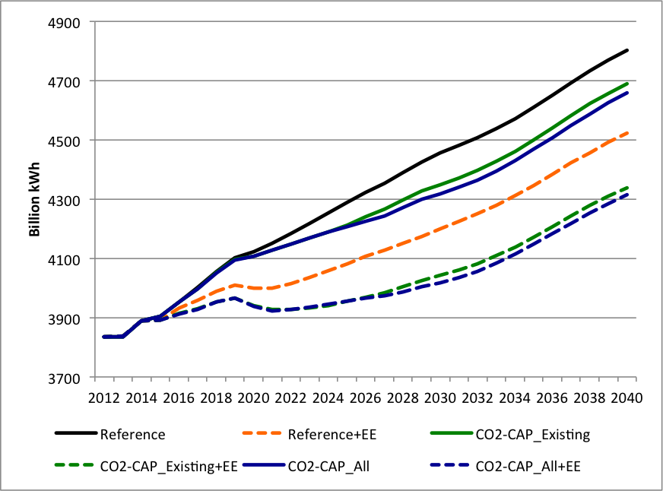
This range of 413-437 TWh exceeds the findings of some studies, but not others. It is lower than the 709 TWh of energy efficiency estimated by Lashof et al. (2014) in their energy-efficiency side case (with an average efficiency costs of 2.7¢/kWh) and less than the 707 TWh of energy efficiency modeled by Brown et al (2015) in their analysis of a tax on carbon in the electricity sector.
Our range is similar to the 457 TWh of cost-effective energy efficiency estimated by Wang and Brown (2014), which is based on modeling a set of similar efficiency policies. Their ex-post analysis of the underlying policy supply curve produces costs ranging from 0.5 to 8.1¢/kWh. EPA (2015a) produces a slightly lower estimate of 325 TWh based on the assumption that each year incremental energy efficiency would grow by 1% of the current annual savings rate. M.J. Bradley & Associates (2016) uses a similar methodology to estimate incremental energy efficiency with a growth rate ranging from 1 to 2%, producing a range with an upper bound that is approximately twice that of EPA: 347-587 TWh.
Several analyses of the CPP have estimated relatively small energy-efficiency gains, such as the 244 TWh estimate by Rhodium (2016) (with average efficiency costs of 7.8¢/kWh), and the 238 TWh estimate by NERA Economic Consulting (2014) (with average efficiency costs of 12.5¢/kWh). At the lowest end of the spectrum are the estimates of incremental energy efficiency under mass-based compliance metrics produced by EIA. The first is from its evaluation of the draft CPP regulations where incremental efficiency was estimated to be 81 TWh in (US EIA, 2015b, Table 18) and the second is from its analysis of the CPP final rule where incremental energy efficiency is estimated to be 76 TWh in 2030 (Martin and Jones, 2016). These studies deploy NEMS, which has conservative assumptions about discount rates and rates of improvement of end-use technologies, which has motivated us to first improve the modeling of energy efficiency in NEMS before deploying it to understand the role that energy efficiency might play in CO₂ mitigation pathways.
The comparison given above demonstrates the improvements of the GT-NEMS modeling approach combined with the scenario assumptions over prior modeling assumptions. The GT-NEMS modeling approach used in this research overcomes some of the conservative and outdated assumptions in NEMS (e.g., slow technology advancement and high discount rates). The GT-NEMS modeling approach used in this research also enables endogenous modeling of energy efficiency, overcoming the shortcomings in prior modeling of energy efficiency as a CO₂ mitigation option. Our GT-NEMS modeling approach does not simply lead to more energy efficiency being deployed and does not represent a simple “energy efficiency boost.” Thanks to the sophisticated and detailed modeling in GT-NEMS, the outcomes are more nuanced, revealing new insights about possible roles for energy efficiency in complying with CO₂ caps, as described below.
  - More affordable CO₂ mitigation
According to the Reference case forecast, electricity prices are expected to rise over the next several decades, increasing from 10.1 ¢/kWh in 2015 to 10.7 ¢/kWh in 2030 nationwide (Figure 2). Prices would be similar or higher in 2030 under all of the mitigation scenarios and they remain higher than Reference case prices in both mitigation scenarios that do not include strong energy efficiency. In contrast, prices in the mitigation scenario with energy efficiency remain lower until 2023, and after rising they return to Reference case prices by 2033 (when regulating existing EGUs) or by 2040 (when regulating all EGUs). Other studies of CO₂ caps have concluded that retail prices would rise above the business-as-usual forecast by 6.9% to 13% in studies by CATF (2014), NERA Economic Consulting (2015), and Rhodium (2015). Energy efficiency does not play as strong a role in these mitigation pathways. The differences across these various modeling efforts again confirm that marginal mitigation costs are likely to be lower with more energy efficiency.
The Bipartisan Policy Center (2016) similarly finds that energy efficiency is important for cost containment. When efficiency is extended beyond the level built into demand projections, efficiency reduces the price of allowances and ERCs under the policy cases, along with the costs for each case relative to the cases without efficiency.
Figure 2. Electricity Prices (in 2013 cents/kWh)
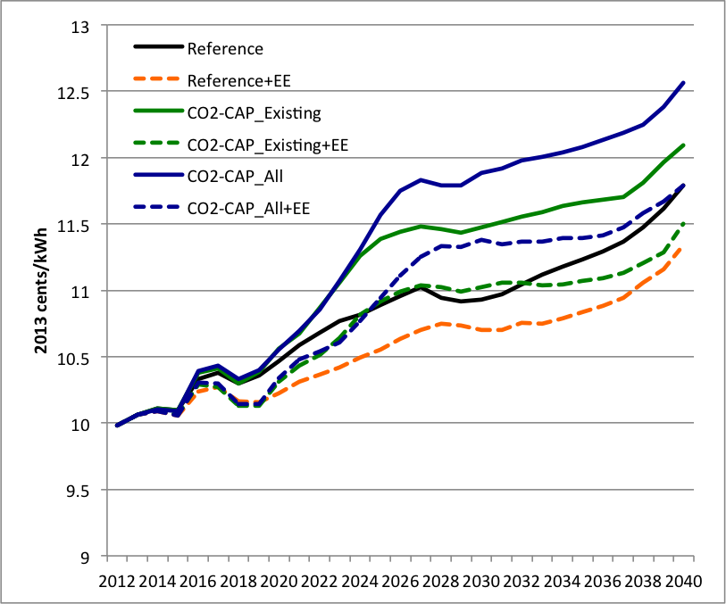
In the Reference case, economy-wide electricity bills per capita (across all customer classes) are expected to increase by 9% between 2012 and 2030 as the result of increasing demand for electrical goods and services as well as increased rates caused by rising fuel costs, environmental regulations, and other factors. When enhanced energy-efficiency policies are added to the Reference case, electricity bills per capita in 2030 would remain at their 2012 level because of reduced demand combined with a more moderate escalation of electricity rates.

Table 1. Impact of the Mitigation Scenarios on U.S. Electricity Bills Per Capita in 2030
Values in ($2013) | Residential Consumers | Businesses | Industries | Total
2012 Baseline | 527.1 | 431.9 | 211.7 | 1172.7
2030 Reference Cases:
Reference | 555.3 | 466.9 | 252.4 | 1278.5
Reference+EE | 489.3 | 451.0 | 229.6 | 1173.7
2030 Mitigation Scenarios:
CO₂-CAP_Existing | 565.0 | 475.4 | 262.0 | 1306.5
CO₂-CAP_Existing+EE | 61.0 | 427.5 | 234.1 | 118.8
CO₂-CAP_All | 577.3 | 488.2 | 271.5 | 1341.2
CO₂-CAP_All+EE | 51.7 | 438.0 | 241.8 | 91.1

In the mitigation scenarios that simply impose carbon constraints, electricity bills would increase by 2% (CO₂-Cap-Existing) and 5% (CO₂-Cap-All) in 2030 above the Reference case forecast. However, with enhanced energy efficiency, the mitigation scenarios generate economy-wide electricity bills per capita that are lower than those forecast for 2030 in the Reference case – by $104.8 in 2030 (in $2013), with similar savings in earlier and later years. These savings allow residential consumers and businesses to invest in efficient equipment and in other goods and services that are generally more labor-intensive and less capital intensive than the power generation that is being displaced.
As indicated in Table 1, residential electricity bills per capita would be $555 (in $2013) in the Reference Case in 2030, totaling nearly $200 billion across the 359 million population of the U.S. projected for that year. Per capita electricity bills would be only $504 in the CO₂-Cap-ALL+EE scenario in 2030, resulting in $53 in savings per capita and $133 per household in that year. Cumulative savings over the 15 years would be much greater, at $1645 per household. Across the U.S., households could experience cumulative electricity savings of $218 billion, where savings are estimated as the difference between the Reference Case forecast and electricity bills from the CO₂-Cap-All+EE scenario. Thus, compliance with CO₂-mass-based goals can be achieved while avoiding the increase in electricity bills forecast by the Reference case.
Mitigation costs in 2030 are estimated by comparing the costs of the Reference case forecast with the costs of each mitigation scenario. We consider three types of costs: the utility resource costs detailed in Table 2 and the energy-efficiency investment and administrative costs detailed in Table 3.
Overall costs of the Reference case are estimated to be $5.16 billion less than the costs of the CO₂-Cap-Existing mitigation scenario and $6.54 billion less than the costs of the CO₂-Cap-All mitigation scenario. In contrast, mitigation costs for the scenarios with strong energy efficiency are lower than the overall costs of the Reference case – by $2.55 billion in the CO₂-Cap-Existing+EE scenario and by $2.95 billion in the CO₂-Cap-All+EE scenario. Thus, the cost reductions enabled by strong energy-efficiency policies would deliver net benefits to the economy.
Comparing costs across scenarios shows how expenses shift depending on the policy path taken. Nine types of utility resource costs are examined. Compared to the Reference case forecast for 2030, four of these types of costs are higher for the mitigation scenarios that do not include strong energy efficiency, but are lower for the mitigation strategies with strong energy-efficiency. Each of these types of utility resource costs are lower when demand is reduced. Installed capacity costs (based on capacity completed in 2030, including financing costs) have the largest range across the scenarios, from $9.4 billion in the CO₂-Cap-All+EE case (where fewer capacity additions are needed because demand is reduced) to $15.9 billion in the CO₂-Cap-All scenario. Transmission costs (the additional costs to connect new plants to the grid), are lower because fewer transmission expansions are needed when demand is reduced. Retrofits of existing capacity are less costly since some of that capacity will be retired with reduced demand. Utility energy-efficiency costs are lower since demand is reduced in the mitigation scenarios principally by programs that are not operated by utilities.
In contrast, four of the nine types of costs are lower across all of the mitigation scenarios compared to the Reference case forecast for 2030. That is, they are lower in the mitigation scenarios with or without strong energy-efficiency policies. Capital additions at existing plants (based on an assumed annual $/KW cost) are lower because of the increased level of plant retirements in the mitigation scenarios, particularly when energy-efficiency policies are added. Fixed O&M costs, fuel expenses, and non-fuel variable O&M costs (annual costs based on NEMS model dispatch decisions) decline because demand is lower in all four scenarios (with or without the addition of energy-efficiency policies). The scenarios without strong energy-efficiency policies have lower demand due to the price elasticity associated with higher energy prices. Fuel expenses have a particularly wide range across the mitigation scenarios, from $36 to $41 billion, compared with $42 billion in the Reference case forecast.

Table 2. Present Value of Utility Resource Costs in 2030 (in Billions $2013)ª
 | Installed capacity | Transmission | Retrofits | Fixed O&M Costs | Capital Additions at Existing Plants | Non-Fuel Variable O&M | Fuel Expenses | Purchased Power | EE Costs | Total  (% Change from Reference Case)
 | Utility Resource Costs
Reference Case | 11.5 | 0.7 | 0.9 | 15.7 | 2.3 | 3.2 | 41.7 | 1.2 | 0.0 | 77.2
Reference+EE | 6.9 | 0.3 | 0.9 | 14.8 | 2.3 | 2.9 | 38.6 | 1.2 | 0.0 | 67.9 (-12.0%)
Mitigation Scenarios:
CO₂-CAP_Existing | 14.0 | 0.8 | 1.0 | 15.4 | 2.0 | 2.9 | 41.4 | 1.4 | 2.4 | 81.3 (5.3%)
CO₂-CAP_Existing+EE | 9.4 | 0.5 | 0.8 | 14.3 | 2.0 | 2.6 | 36.6 | 1.3 | 0.0 | 67.5 (-12.5%)
CO₂-CAP_All | 15.9 | 0.8 | 1.0 | 15.8 | 2.0 | 2.7 | 40.4 | 1.6 | 2.4 | 82.6 (6.9%)
CO₂-CAP_All+EE | 9.4 | 0.5 | 0.9 | 14.6 | 2.0 | 2.4 | 36.3 | 1.5 | 0 | 67.6 (-12.5%)
 | Utility Resource Mitigation Costs
CO₂-CAP_Existing | 2.5 | 0.1 | 0.1 | -0.3 | -0.3 | -0.3 | -0.3 | 0.2 | 2.4 | 4.1
CO₂-CAP_Existing+EE | -2.1 | -0.2 | -0.1 | -1.4 | -0.3 | -0.6 | -5.1 | 0.1 | 0 | -9.7
CO₂-CAP_All | 4.4 | 0.1 | 0.1 | 0.1 | -0.3 | -0.5 | -1.3 | 0.4 | 2.4 | 5.4
CO₂-CAP_All+EE | -2.1 | -0.2 | 0 | -1.1 | -0.3 | -0.8 | -5.4 | 0.3 | 0 | -9.6
ª The present values are calculated using a 7% discount rate. Utility resource costs in 2030 are the difference between the utility resource costs forecast for 2030 and the cost of each mitigation scenario. The estimates of utility resource costs are generated by GT-NEMS, based on each scenario’s assumptions about technology costs, demand growth, fuel prices, etc.
Purchased power costs are the only expense that is higher in all of the mitigation scenarios than in the Reference case forecast in 2030. These expenses include purchases from cogenerators and the cost of net imports.
In total, utility resource costs would be approximately $4-5 billion (5-7%) higher than the Reference case in the two scenarios that do not include strong energy-efficiency policies. In contrast, they would be approximately $10 billion (12%) lower in both scenarios that include strong energy-efficiency policies.
Table 3 displays the incremental energy-efficiency costs associated with the non-utility policies and programs modeled in this paper. These policies are not rate-based by the utility sector and in fact displace some of the utility’s energy-efficiency program costs. By including strong local, state, and federal programs, additional utility energy-efficiency programs are not cost-effective.

Table 3. Present Value of Mitigation Costs in 2030 (in Billions $2013)ª
 | Utility Resource  Mitigation Costs | Energy-Efficiency Investment Premiums |  |  |  |  | Energy-Efficiency Administrative Costs |  |  |  | Total Mitigation Costs
 |  | Households | Business | Industry | Subtotal |  | Households | Business | Industry | Subtotal
CO₂-CAP_  Existing | 4.1 | 0 | 0 | 1.06 | 1.06 |  | 0 | 0 | 0 | 0 | 5.16
CO₂-CAP_  Existing+EE | -9.7 | 2.36 | 1.24 | 3.41 | 7.01 |  | 0.07 | 0.01 | 0.06 | 0.14 | -2.55
CO₂-CAP_  All | 5.4 | 0 | 0 | 1.14 | 1.14 |  | 0 | 0 | 0 | 0 | 6.54
CO₂-CAP_  All+EE | -9.6 | 2.38 | 0.69 | 3.44 | 6.51 |  | 0.07 | 0.01 | 0.06 | 0.14 | -2.95

ª Present value of mitigation costs are calculated using a 7% discount rate. Incremental energy-efficiency costs are calculated from the detailed outputs from GT-NEMS, supplemented by offline calculations to fill gaps in the industrial sector and to estimate administrative cost using methodologies described in the Technical Appendix.
There are two components of these costs: the incremental end-user investment costs that purchase the “energy-efficiency premium” and the administrative cost of implementing the policies needed to motivate these investments. The energy-efficiency premium is the cost of the added increment of energy efficiency – the incremental cost of a highly efficient boiler, refrigerator, air conditioner, or motor, compared with standard practice (IEA, 2014, p. 33). In 2030, these range from $1.1 billion in CO₂-Cap-All (in addition to the $2.4 billion estimated to be spent on the energy-efficiency programs administered by utilities) to $7.0 billion in the CO₂-Cap-Existing+EE scenario that displaces the utility programs. The costs for administering the strong energy-efficiency policies are estimated to be $140 million. Thus, in addition to overall cost reductions with the introduction of strong energy-efficiency policies, there is a shift of cost from rate-based utility programs paid for by all ratepayers through higher energy prices, to investments by households, businesses, and industry that purchase more efficient equipment and upgrade their buildings and structures.
  - Reduced Investment in New Natural Gas Plants
In the carbon reduction strategies that do not include enhanced energy efficiency, natural gas generation expands quickly and more rapidly than in the Reference case, starting before the compliance period as utilities foresee the need to achieve carbon goals by 2025, and growing rapidly through the compliance period, meeting an increasing portion of U.S. electricity demand (Figure 3). Generation from natural gas units, the capacity of natural gas units, and natural gas prices to the power sector all increase. These effects are significantly tempered in the scenarios with strong energy-efficiency policies.
Figure 3. Electricity Generation from Natural Gas
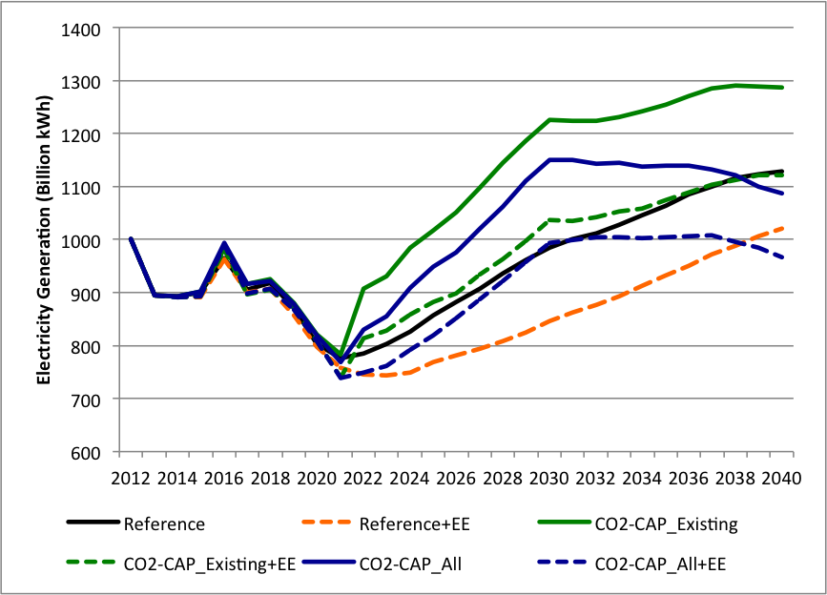
The mitigation scenarios generally favor NGCC new builds (particularly in the absence of energy efficiency), since these are the most efficient and carbon-lean of the natural gas generation systems with the exception of natural gas cogeneration. Without the inclusion of strong energy efficiency, the mitigation scenarios also grow the nation’s fleet of combustion turbines and diesel generators despite the fact that this equipment is relatively inefficient. All four mitigation scenarios accelerate the retirement of oil and natural gas steam generators, which tend to be both old and inefficient. The inclusion of strong energy-efficiency policies also curbs the rush to build more combined cycle natural gas plants. Specifically, compliance with the CPP could produce a 59% increase in the capacity of natural gas combined cycle power plants over the next 25 years. With enhanced energy efficiency, this could be reduced to a 13% increase. Thus, the expense of rapidly constructing natural gas infrastructure is tempered (Figure 4). The mitigation scenarios with strong energy-efficiency policies also slow the growth of wind and solar.
Figure 4. Capacity of Natural Gas (and Oil and Diesel) Generators (in GW)
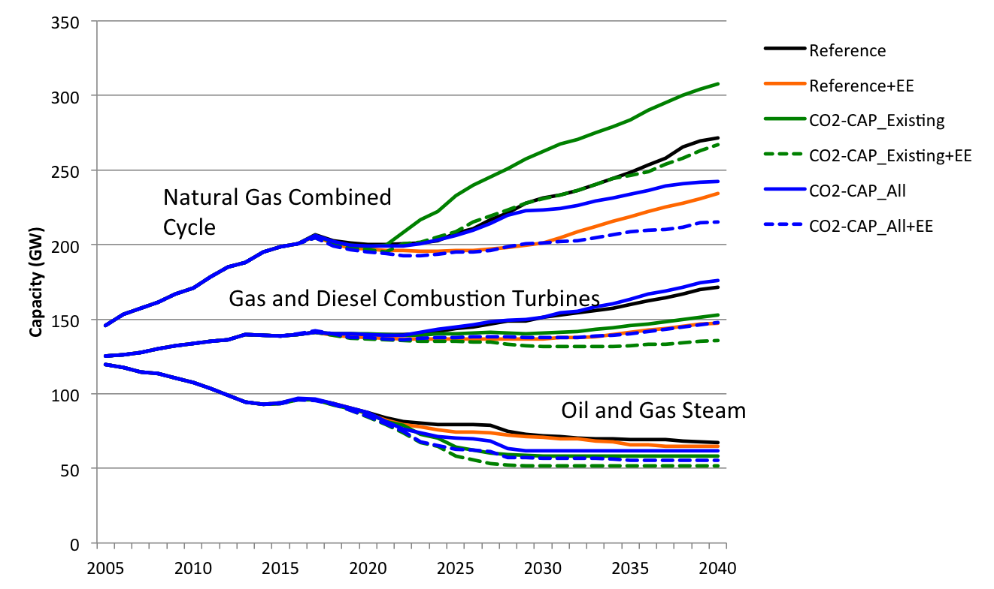

  - Carbon Leakage Mitigation
In the absence of new policies, CO₂ emissions from the power sector are forecast to increase steadily through 2040, at an average annual growth rate of 0.2% (Table 4 and Figure 5). Because this is lower than the assumed rate of growth of the population and GDP, CO₂ emissions per capita and the carbon intensity of the economy are forecast to continue to decrease, as has been the trend for more than a decade.

Table 4. CO₂ Emissions Across Mitigation Scenarios (Million Short Tons, Lower 48 State)ª
Scenarios | 2012 | 2030
 | Electric Sector Total | Affected Existing EGUs | All Affected EGUs  (Existing & New) | Electric Sector
 |  |  |  | Total | % Change from 2012 | % Change from Reference in 2030
Reference Cases:
Reference Case | 2,243 | 2,130 | 2,289 | 2,315 | 3.2% | --
Reference+EE | -- | 2,128 | 2,208 | 2,232 | -0.5% | -3.6%
Mitigation Scenarios:
CPP_Existing | -- | 1,631 | 1,897 | 1,920 | -14.4% | -17.1%
CPP_Existing+EE | -- | 1,627 | 1,812 | 1,833 | -18.3% | -20.8%
CPP_All | -- | 1,678 | 1,749 | 1,786 | -20.4% | -22.9%
CPP_All+EE | -- | 1,676 | 1,736 | 1,762 | -21.5% | -23.9%
ª A metric ton (1,000 kilograms) is 1.10231 times larger than a short ton (2,000 pounds).
Figure 5. Trajectories of CO₂ Emissions
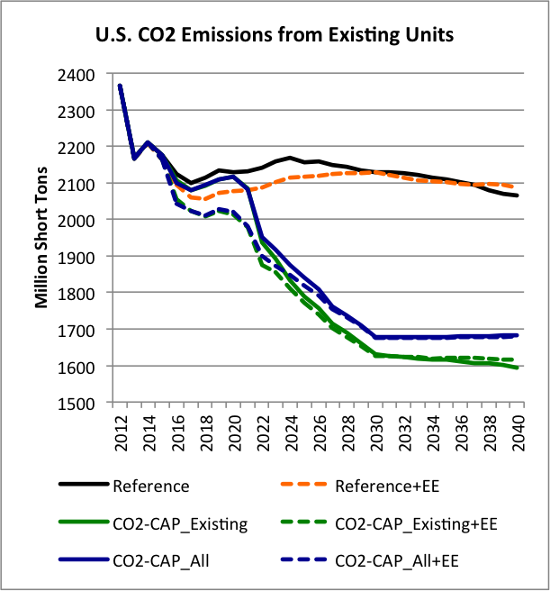 | 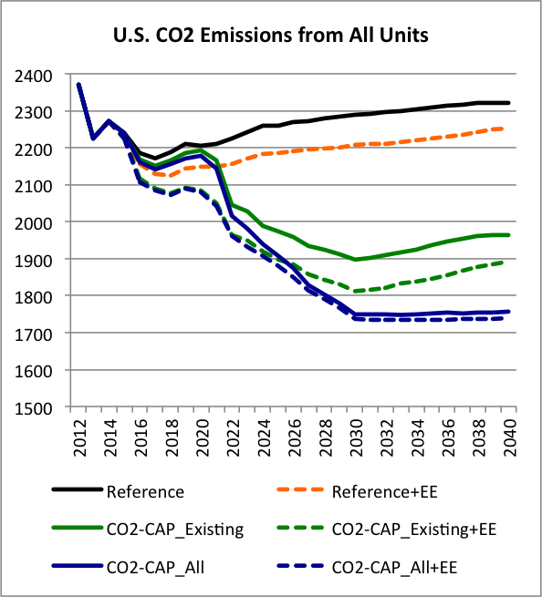
ª CO₂ emissions are calculated for the lower 48 states only.
Figure 5 distinguishes between emissions from fossil EGUs that are covered by the CPP and all units, which include fossil units such as small combustion turbines that are not regulated under the CPP. Emissions from affected units decline steeply from 2022 through 2030, when the mass-based goals are assumed to be imposed as a standalone policy. They begin to decline earlier under the scenarios with strong energy-efficiency policies.
Following the global economic downturn of 2008 and fuel switching away from coal to low-cost natural gas, CO₂ emissions in the U.S. declined; the electric sector in 2012 emitted 2,243 short tons of CO₂, down 16% from the 2,664 tons of emissions in 2005. But as the economy recovers going forward, the Reference case forecasts that CO₂ emissions from the electric sector will rise, producing an upward trajectory of CO₂ emissions that is inconsistent with long-term climate change goals.
The CO₂ emissions that could result from a range of alternative scenarios are shown in Table 4. The scenario that limits emissions from both existing and new units (that is, the “CO₂-Cap-All” scenario) would result in power sector CO₂ emissions of only 1,802 short tons in 2030, 32% less than in 2005 and 20% less than in 2012. This is the magnitude of reductions forecast in EPA (2015a)’s Regulatory Impact Analysis. By adding strong energy-efficiency policies to the “CO₂-Cap-All” scenario, CO₂ emissions are reduced further, by 34% relative to 2005 and 21% relative to 2012.
Electric-sector emissions are higher when only existing units are regulated, as shown by the “CO₂-Cap-Existing” scenario in Table 2, which results in 1,979 million short tons of CO₂ emissions in 2030. This is 177 million short tons of CO₂ more than the CO₂-Cap-All scenario, when emissions of all units are regulated; it is a reduction of only 26% less than in 2005 (12% less than in 2012), which would significantly weaken the policy. When strong energy-efficiency policies are added to the CO₂-Cap-Existing scenario, carbon leakage drops from 177 to 32 million short tons of CO₂ (an 82% reduction), indicating that the magnitude of leakage could indeed be reduced by measures that decrease future demand such as energy efficiency. Wright and Kanudia (2016) concluded that mass-based designs that exclude new NGCC plants from their goals were among their highest emissions scenarios (reducing emissions by only 6-8% below 2012 levels by 2032), which suggests a much higher level of leakage than we documented. Their exogenous modeling of energy efficiency concluded that energy efficiency could reduce new source leakage. Our endogenous modeling of energy efficiency substantiates this claim, linking the reduced leakage to the reduced need for new capacity builds.

5.4 Compliance with CO₂ Caps Increases Abatement of Non-CO₂ Pollutants
Overall, compliance with CO₂ Caps is expected to reduce emissions of CO₂ and also to produce co-benefits associated with lower local air pollution. The co-benefits estimated here are the benefits that go beyond those achieved by previous EPA rulemakings and other promulgated policies, since these past policies are built into the Reference Case.
We estimate the global social cost of carbon (SCC) using EPA’s CPP Regulatory Impact Analysis (EPA, 2015a). The SCC is a metric that estimates the monetary value of impacts associated with CO₂ emission reductions in a given year. We focus on the single year 2030, and we use the 3% discount rate applied to a ton of CO₂ emissions in 2030, which corresponds to $55 (in $2011) per metric ton of CO₂ as reported in EPA (2015a) Table 4-2. This value equates to $51.7 (in $2013) per short ton of CO₂ in 2030.
The mitigation scenarios offer additional environmental and health benefits, which are called co-benefits because they are not the primary benefit being targeted by the regulation. The most studied of these co-benefits are the criteria air pollutants that are reduced when fossil-fuel electricity generation decreases. Estimated emissions of three of these pollutants – sulfur dioxide (SO₂), and nitrogen oxide (NOx) – are summarized in Table 5.
Table 5. Electric Power Sector Emissions in the U.S. in 2012 and 2030ª
 | Carbon Dioxide |  | Sulfur Dioxide |  | Nitrogen Oxide
Scenario | Million Short Tons | % Change from Reference in 2030 | Million Short tons | % Change from Reference in 2030 | Million Short tons | % Change from Reference in 2030
2012 Baseline | 2,243 |  | 3.43 |  | 1.68
2030 Reference Cases
Reference | 2,315 |  | 1.41 |  | 1.51
Reference+EE | 2,232 | -4% | 1.37 | -3% | 1.46 | -3%
2030 Mitigation Scenarios
CO₂-CAP_Existing | 1,920 | -17% | 1.01 | -28% | 1.12 | -26%
CO₂-CAP_Existing+EE | 1,833 | -21% | 1.00 | -29% | 1.08 | -28%
CO₂-CAP_All | 1,786 | -23% | 0.89 | -37% | 1.02 | -33%
CO₂-CAP_All+EE | 1,762 | -24% | 0.93 | -34% | 1.04 | -31%
ª A metric ton (1,000 kilograms) is 1.10231 times larger than a short ton (2,000 pounds).
“% Change” is based on the difference between the mitigation scenario in 2030 and the Reference case forecast for 2030.
By combining these with estimated benefits-per-ton of reduced CO₂, SO₂ and NOx developed by EPA (EPA, 2015a), Table 6 provides the estimated benefits of decreasing these air pollutants in the year 2030. Specifically, the mitigation scenarios would produce estimated co-benefits ranging from $43 to $100 billion (in $2013) in 2030, similar to the estimate of $33 to $86 billion (in $2012) in 2030 estimated by M.J. Bradley (2015, p. 20).

Table 6. Total Benefits of Reducing CO₂, Sulfur Dioxide, and Nitrogen Oxides in 2030ª
Monetized benefits  in 2030 (in billions $2013) | Carbon Dioxide | Sulfur Dioxide | Nitrogen Oxide | Total
2030 Reference Case
Reference Case+EE | 4.3 | 1.7 - 4.0 | 0.5 – 1.6 | 6.5 – 9.9
2030 Mitigation Scenarios
CO₂-CAP_Existing | 20.4 | 18.1 - 41.1 | 4.7 – 14.9 | 43.2 – 76.5
CO₂-CAP_Existing+EE | 24.9 | 18.6 - 42.3 | 5.2 – 16.4 | 48.7 – 83.6
CO₂-CAP_All | 27.4 | 23.6 - 53.6 | 5.9 – 18.8 | 56.9 – 99.8
CO₂-CAP_All+EE | 28.6 | 21.8 - 49.6 | 5.7 – 17.9 | 56.1 – 96.1
ª The benefits from reducing non-CO₂ pollutants are estimated as ranges because EPA provides a range of co-benefit multipliers through which to estimate them.

Our analysis indicates that policies for leakage can strongly influence the impact of energy efficiency on non-CO₂ pollutants. Specifically, the addition of strong energy-efficiency policies to the CO₂-Cap-All scenario, reduces these collateral benefits, while it increases the collateral benefits in the CO₂-Cap-Existing scenario. Coal capacity is not reduced as much when energy efficiency is added to the CO₂-Cap-All case, and coal generation is forecast to be greater in the CO₂-Cap-All+EE case, compared to CO₂-Cap-All. This same finding was noted in BPC (2016), where policy scenarios with demand and supply side efficiency options allow more coal generation and, as a result, do not build as much new NGCC or renewable generation.
This is further revealed in Figure 6. In the CO₂-Cap-All+EE scenario, natural gas grows more slowly, reaching approximately 1,315 billion kWh in 2030, compared with 1,468 billion kWh in the CO₂-Cap-All case. The same is true of wind and solar, which grow to only 362 billion kWh and 88 billion kWh in CO₂-Cap-All-EE, while they reach 502 billion kWh and 118 billion kWh in CO₂-Cap-All. Coal generation on the other hand is larger in the CO₂-Cap-All+EE case, reaching 1,183 billion kWh compared with 1,140 billion kWh in the CO₂-Cap-All case.
Each of the mitigation scenarios would increase nearly all of renewable resources in 2030, compared to the Reference case. In the Reference case, the magnitude of renewables generation is expected to grow by 51% between 2012 and 2030, mostly by the growth of wind and solar. This growth would be expanded by 88% in the CO₂-Cap-Existing scenario, 63% in CO₂-Cap-Existing+EE, 112% in CO₂-Cap-All, and 76% in CO₂-Cap-All+EE in 2030. The response to the scenarios is distinct between utility-scale and distributed generation. In the CO₂-Cap-All scenario, utility-scale renewable resources of electricity increase from 462 billion kWh in 2012 to 969 billion kWh in 2030 (a 110% increase). Distributed renewable resources grow from 39 billion kWh in 2012 to 94 billion kWh in 2030 (a 143% increase). By adding strong energy-efficiency policies to the “CO₂-Cap-All” scenario, utility-scale renewable generation grows by only 70% in 2030. However, the growth of distributed renewable resources is continuously accelerated by 143% in 2030 even though demand shrinks with the push on energy efficiency.
Figure 6. Impact of Mitigation Scenarios on the U.S. Fuel Mix
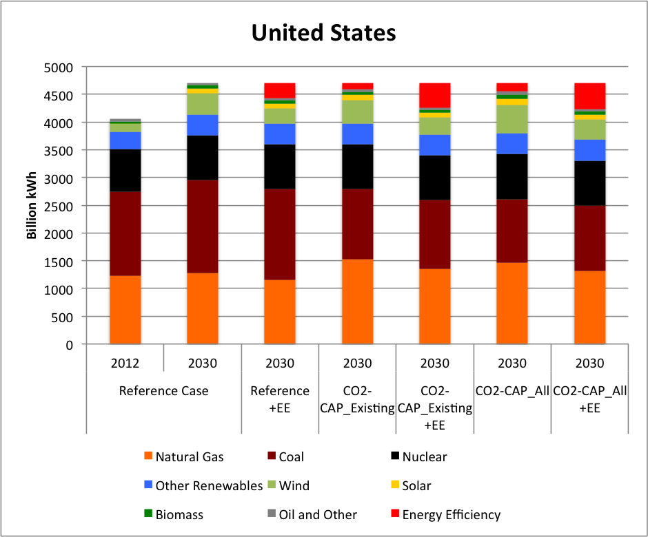
- Conclusions and Policy Implications
In addressing the research question of what integrated analysis would reveal about the role of energy efficiency in carbon mitigation pathways, we have shown that energy efficiency plays many important roles. First and foremost, the clean power transformation can be made more affordable by improving the efficiency of energy utilization. Ceteris paribus, per capita electricity bills are forecast to increase over the next 15 years, and if carbon caps are not wisely implemented, they could lead to even higher energy bills. With strong energy-efficiency policies, the growth of energy consumption and the escalation of energy rates could be constrained, bringing electricity bills back to 2012 levels. Total resource costs of the electricity sector are also lower in the mitigation pathways that include strong energy-efficiency policies, and these savings exceed the incremental investment cost of consumers.
The modeling clearly illustrates that strong energy-efficiency policies in the U.S. would reduce the construction of new NGCC plants and the long-term lock-in of natural gas. Specifically, compliance with the CPP could produce a 59% increase in the capacity of NGCC plants over the next 25 years; this could be cost-effectively reduced to a 13% increase by improving the efficiency of energy utilization.
The mitigation of carbon leakage by strong energy-efficiency policies is also documented. Specifically, the 177 million short tons of carbon leakage that occurs in 2030 when only existing power plants are regulated is reduced 82% by energy-efficiency measures. This finding underscores the importance of adopting leakage-mitigation strategies when using mass-based CO₂ caps. It also highlights the legacy impacts of near-term investments, underscoring the need to consider long-term consequences when designing carbon mitigation policies (Murray, Pizer, and Martin, 2015).
We find that the abatement of local pollutants – a common co-benefit of CO₂ mitigation – may not be consistently delivered when energy efficiency is strengthened in mass-based mitigation designs because the constrained demand growth allows more coal generation. In turn, less natural gas and renewables generation are built. Such coal plant life extension effects can be mitigated by supplementary policies such as renewable portfolio standards or by extending the CEIP. In general, single-pollutant regulations may not optimize impacts across pollutants, necessitating such additional measures.
Overall, this paper demonstrates the value of integrated carbon mitigation modeling where demand- and supply-side options are co-optimized. Looking ahead, modeling tools at the state level are needed so that state agencies and stakeholders can more thoroughly examine the role of both demand- and supply-side mitigation pathways. This will inform both domestic climate policies and compliance strategies to meet the Paris Accord. There is also a need to develop technical reference manuals, energy-efficiency registries, and guidelines for verifying demand-side carbon reductions. Such resources will help reduce the perceived risk and enhance the certainty associated with exploiting the potential of energy efficiency in carbon mitigation pathways.

References
Barbose, G. and Darghouth, N., 2015. Tracking the Sun VIII: An Historical Summary of the Installed Price of Photovoltaics in the United States from 1998 to 2014. Berkeley, CA: Lawrence Berkeley
Bianco, Nicholas, Litz, F., Meek, K., and Gasper, R., 2013. Can the U.S. Get There from Here? Using Existing Federal Laws and State Action to Reduce Greenhouse Gas Emissions, World Resources Institute, (http://www.wri.org/publication/can-us-get-there-here).
Bipartisan Policy Center, 2016. “Modeling the Evolving Power Sector and Impacts of the Final Clean Power Plan.” Available at: http://cdn.bipartisanpolicy.org/wp-content/uploads/2016/06/BPC-Energy-Clean-Power-Plan-Modeling.pdf.
Bolinger, M. amd Seel, J., 2015. Utility-Scale Solar 2014: An Empirical Analysis of Project Cost, Performance, and Pricing Trends in the United States. Berkeley, CA: Lawrence Berkeley
Brandt, A.R., Heath,G.A., Kort,E.A., O’Sullivan, F.,Pétron, G., Jordaan,S.M., Tans,P., Wilcox,J., Gopstein,A.M., Arent,D., Wofsy,S., Brown,N.J., Bradley,R., Stucky,G. D., Eardley,D., Harriss,R., 2014.Methane leaks from north American natural gas systems. Science 343,733–735.
Brown, M.A., G. Kim, and A.M. Smith, 2015. Low-Carbon Electricity Pathways for the U.S. and the South: An Assessment of Costs and Options, School of Public Policy, Georgia Institute of Technology, Working Paper #86, http://www.spp.gatech.edu/publications/working-papers/low-carbon-electricity-pathways-us-and-south-assessment-costs-and
Brown, M.A., Matt Cox, and Rodrigo Cortes, 2010. “Transforming Industrial Energy Efficiency,” The Bridge (Washington, DC: National Academy of Engineering), Fall, pp. 22-30.
Brown, Marilyn A., Paul Baer, Matt Cox, and Jae Kim. 2014. “Evaluating the Risks of Alternative Energy Policies: A Case Study of Industrial Energy Efficiency,” Energy Efficiency, 7(1): 1–22.
Brown, M.A., W. Short and M. D. Levine (eds.), 2001. Scenarios for a Clean Energy Future, Energy Policy, Vol. 29, Special issue 14.
Brown, Marilyn A. and Yu Wang. 2017. “Energy-Efficiency Skeptics and Advocates: The Debate Heats Up as the Stakes Rise,“ Energy Efficiency, http://link.springer.com/article/10.1007/s12053-017-9511-x.
Brown, Marilyn A., and Yu Wang, 2015. Green Savings: How Policies and Markets Drive Energy Efficiency, Praeger Press.
Brown, Marilyn A.,; Mark D. Levine,; Walter Short, andt; Jonathan G. Koomey, 2001. “Scenarios for a Clean Energy Future,” Energy Policy, 2001, 29 (14): 1179-1196.
Burtraw, D., J. Linn, K. Palmer, and A. Paul, 2016. “Approaches to Address Potential CO₂ Emissions Leakage to New Sources under the Clean Power Plan.” Resources for the Future. http://www.rff.org/research/publications/approaches-address-potential-co2-emissions-leakage-newsources-under-clean.
Burtraw, D., Woerman, M., & Paul, A., 2012. Retail electricity price savings from compliance flexibility in GHG standards for stationary sources. Energy Policy, 42, 67–77.
Bushnell, James, Stephen P. Holland, Jonathan E. Hughes and Christopher R. Knittel. "Strategic Policy Choice in State Level Regulation: The EPA's Clean Power Plan" Forthcoming at the American Economic Journal: Economic Policy.
Marc Chesney, J. Gheyssens, A.C. Pana, and L. Taschini. 2016. Environmental Finance and Investments, Springer, Second edition.
Clean Air Task Force (CATF), 2014. Comments of Clean Air Task Force on the Clean Power Plan http://www.catf.us/resources/filings/EGU_GHG_NSPS_Rule/CATF%20CPP%20Comments.pdf
Cox, Matt, Marilyn A. Brown, and Xiaojing Sun, 2013. “Energy Benchmarking of Commercial Buildings: A Low-cost Pathway for Urban Sustainability,” Environmental Research Letters, Vol. 8 (3), pp. 1-12, http://iopscience.iop.org/1748-9326/8/3/035018/pdf/1748-9326_8_3_035018.pdf.
Cullenward, D., Wilkerson, J. T., Wara, M., Weyant, J. P. 2016. Dynamically estimating the distributional impacts of US climate policy with NEMS: A case study of the Climate Protection Act of 2013. Energy Economics, 55, 303-318.
Eldridge, Maggie, et al., 2008. State-level Energy Efficiency Analysis: Goals, Methods, and Lessons Learned (Washington, DC: American Council for an Energy-Efficient Economy, http://aceee.org/files/proceedings/2008/data/papers/8_468. pdf.
Electric Power Research Institute, 2016. “State-Level Modeling of Clean Power Plan Compliance Pathways with EPRI’s US-REGEN Model.” Available at: http://www.rff.org/files/document/file/160211_CPPModelingForStrategicInsights_Niemeyer_0.pdf.
Espey, J. A., & Espey, M. (2004). Turning on the lights: A meta-analysis of residential electricity demand elasticities. Journal of Agricultural and Applied Economics, 36(1), 65-82.
Feng, K., S.J. Davis, L. Sun, and K. Hubacek. 2015. “Drivers of US Co2 Emissions 1997-2013,” Nature Communications, 6, http://www.nature.com/articles/ncomms8714.
GTM/SEIA, 2015. Solar Market Insight Report 2015 Q1, Q2.
Hausfather, Zeke, 2015. Bounding the climate viability of natural gas as a bridge fuel to displace coal. Energy Policy 86 (2015) 286–294. http://dx.doi.org/10.1016/j.enpol.2015.07.012.
Hausker, Karl, Meek, K.. Gasper, R., Alden, N., and Obeiter, M., 2015. Delivering on the U.S. Climate Commitment: A 10-Point Plan Towward a Low-Carbon Future,” World Resources Institute.
International Energy Agency (IEA). 2014. Energy Efficiency Market Report 2014 (Paris: IEA).
IEA. 2016. World Energy Outlook 2016. Chapter 8: Energy and Climate Change, pp. 313-346.
Larsen, John, Sarah Ladislaw, Michelle Melton, and Whitney Herndon, 2016a. Assessing the Final Clean Power Plan: Emissions Outcomes. Center for Strategic and International Studies. Washington, DC: Rhodium Group.
Lashof, D., Yeh, S., Bryk, D., Carter, S., Doniger, D., Murrow, D., & Johnson, L., 2014. Cleaner and Cheaper: Using the Clean Air Act to Sharply Reduce Carbon Pollution from Existing Power Plants, Delivering Health, Environmental, and Economic Benefits. Washington, DC: Natural Resources Defense Council. Retrieved from http://www.nrdc.org/air/pollution-standards/files/pollution-standards-IB- update.pdf
Litz, F. and B. Murray, 2016. Mass-Based Trading under the Clean Power Plan: Options for Allowance Allocation. NI WP 16-04, Durham, NC: Duke University.
M.J. Bradley & Associates LLC, 2016. EPA’s Clean Power Plan: Summary of IPM Modeling Results (Boston, MA: M.J. Bradley & Associates LLC).
Martin, Laura, and Jeffrey Jones, 2016. Effects of the Clean Power Plan (Washington, DC: Energy Information Administration), DOE/EIA-0383(2016), June.
Murray, Brian C., William A. Pizer, and Martin T. Ross, 2015. Regulating Existing Power Plants under the U.S. Clean Air Act: Present and future consequences of key design choices, Energy Policy (83): 87-98.
National Academies, 2016. The Power of Change: Innovation for Development and Deployment of Increasingly Clean Electric Power Technologies (Washington, DC: National Academies)
NERA Economic Consulting, 2015. Energy and Consumer Impacts of EPA’s Clean Power Plan, http://www.americaspower.org/wp-content/uploads/2015/11/NERA-CPP-Final-Nov-7.pdf.
Peters, Jeffrey C. and Thomas W. and Hertel, 2016. Achieving the Clean Power Plan 2030 CO₂ Target with the New Normal in Natural Gas Prices, The Energy Journal, forthcoming.
Resources for the Future, 2016. “Lessons for Reducing Leakage to Uncovered Sources under the Clean Power Plan.” Available at: http://www.rff.org/files/document/file/Burtraw_CPP%20Leakage%20160823_dis.pdf.
Rhodium Group and Center for Strategic & International Studies, 2016. “Assessing the Final Clean Power Plan Energy Market Impacts.” Available at: http://rhg.com/wp-content/uploads/2016/05/AssessingCleanPowerPlan_EMI.pdf.
Ross, M., D. Hoppock, & B. Murray, 2015. Assessing Impacts of the Clean Power Plan on Southeast States (No. 15-03). Durham, NC.
Shearer, Christine, J. Bistline, M. Inman, & S. J. Davis, 2014. The effect of natural gas supply on US renewable energy and CO₂ emissions. Environmental Research Letters 9 (2014) 094008 (8pp) doi:10.1088/1748-9326/9/9/094008.
Smith, Alexander and Marilyn A. Brown. 2015. “Demand Response: A Carbon Neutral Resource?” Energy 85 (2015) 10-22.
Thomas, Brinda Ann, Z. Hausfather, & I. L. Azevedo, 2014. Comparing the magnitude of simulated residential rebound effects from electric end-use efficiency across the US. Environmental Research Letters 9 (2014) 074010 (13pp) doi:10.1088/1748-9326/9/7/074010.
U.S. Energy Information Administration (US EIA), 2014a. Integrating module of the national energy modeling system: Model documentation 2014. Retrieved from http://www.USEIAUS EIA.gov/ forecasts/aeo/nems/documentation/integrating/pdf/m057%282014%29.pdf.
U.S. EIA, 2009. The National Energy Modeling System: An Overview. Retrieved from http://www.eia.gov/oiaf/aeo/overview/
U.S. EIA, 2014b. Residential demand module of the national energy modeling system: Model documentation 2014. Retrieved from http://www.eia. gov/forecasts/aeo/nems/documentation/residential/pdf/m067%282014%29.pdf.
U.S. EIA, 2015a. Annual Energy Outlook 2015. Washington, DC: U.S. Energy Information Administration.
U.S. EIA, 2015b Analysis of the Impacts of the Clean Power Plan, Washington, DC: U.S. Energy Information Administration, May.
U.S. EIA, 2015c. The national energy modeling system. Retrieved from http://www.eia.gov/oiaf/aeo/overview/index.html
U.S. EIA, 2015d. Updated Buildings Sector Appliance and Equipment Costs an Efficiencies, Washington, DC: U.S. Energy Information Administration.
U.S. EIA, 2016. Preliminary Monthly Electric Generator Inventory, Feburary 26, 2016. http://www.eia.gov/electricity/data/eia860m/. Accessed in March 13, 2016.
U.S. Environmental Protection Agency (EPA), 2015a. Regulatory Impact Analysis for the U.S. Environmental Protection Agency. “Regulatory Impact Analysis for the Clean Power Plan Final Rule.” Available at: https://www.epa.gov/sites/production/files/2015-08/documents/cpp-final-rule-ria.pdf.
U.S. EPA, 2015b. Demand-Side Energy Efficiency Technical Support Document. Available at: https://www.epa.gov/sites/production/files/2015-11/documents/tsd-cpp-demand-side-ee.pdf Proposed Carbon Pollution Guidelines for Existing Power Plants and Emission Standards for Modified and Reconstructed Power Plants.
U.S. EPA, 2016. Inventory of Greenhouse Gas Emissions and Sinks: 1990-1914. Available at: https://www.epa.gov/sites/production/files/2016-04/documents/us-ghg-inventory-2016-main-text.pdf.
Wang, Joy Huan. 2016. Energy Information at Home: An Analysis and Policy Projection of the Rebound Effect and U.S. Smart Grid, PhD Dissertation, Georgia Institute of Technology. December
Wang, Y., & Brown, M. A., 2014. Policy Drivers for Improving Electricity End-Use Efficiency in the U.S.: An Economic-Engineering Analysis. Energy Efficiency, 7(3), 517–546.
Wilkerson, J. T., Cullenward, D., Davidian, D., & Weyant, J. P., 2013. End Use Technology Choice in the National Energy Modeling Systems (NEMS): An Analysis of the Residential and Commercial Building Sectors. Energy Economics, 40, 773–784.
Wright, E. and A. Kanudia, 2016. Variation in Outcomes and Leakage Potential Across Clean Power Plan Compliance Designs, Energy Economics, forthcoming.
Zhang, X., N. Myhrvold, & K. Caldeira, 2014. Key factors for assessing climate benefits of natural gas versus coal electricity generation, Environmental Research Letters 9 (2014) 114022 (8pp) doi:10.1088/1748-9326/9/11/114022.

40 CFR Part 60 "Carbon Pollution Emission Guidelines for Existing Stationary Sources: Electric Utility Generating Units" (80 Fed. Reg. 64662, Oct. 23, 2015)
2.3-3.2 cents/KWh represents only 55% of the total resource cost of energy-efficiency investments, assumed to be the utility portion of ratepayer funded EE; the assumed total resource cost is 4.2-5.8 cents/KWh.
http://www.eia.gov/todayinenergy/detail.cfm?id=26492
http://energy.gov/articles/energy-department-announces-largest-energy-efficiency-standard-history
The methodology of investment cost calculation can be found at Appendix Section F.

